

**School of Computing, Engineering and Physical Sciences**

**MSc Information Technology**

**COMP11112 Enterprise Architecture**

**GROUP COURSEWORK**

**Session 2024/2025 Term 1**

**Students**

1. Prajwalaradhya Shivakumaraswamy Kesaramadu (B01759301)
2. Aman Misra (B01746656)
3. Sreeraj Karuvanthodi Ramachandran (B01764963)

Lecturer: Dr Volkan Tunali

Submission Date: 19-12-2024

**Declaration**

I have carefully read and fully understand Regulations 3.49–3.55 of Chapter 3 of the Regulatory Framework of the University of the West of Scotland, which outline the rules and policies regarding cheating and plagiarism.

I confirm that this assessment is the collective work of our group, with each member contributing to the completion of this task. Where applicable, we have clearly referenced and acknowledged the contributions or ideas of others outside our group.

I also affirm that no part of this assessment has been written, in whole or in part, by anyone outside the group, except for explicitly referenced sources.

Furthermore, I confirm that this assessment has not been submitted previously, either partially or fully, for any other module or academic purpose, ensuring it does not fall under self-plagiarism.

This declaration is made with honesty and integrity in adherence to the University’s academic standards.

Table of Contents

**Contribution Table** 4

**Business Context Diagram** 5

**UML Activity Diagram with Horizontal Swimlanes** 6

1. DVD Ordering 6

2. DVD Renting 6

3. DVD Returning 7

4. DVD Reservation 7

**UML Use-Case Diagram** 8

**UML Activity Diagram with Vertical Swimlanes** 9

**UML Class Diagram** 10

**Service Interaction Diagram** 11

**Service Interface Diagram** 11

1. DVD Rental Service 11

2. Customer Service 12

3. Scanning Service 12

4. Inventory Service 12

5. Payment Service 12

# **Contribution Table**

|  |  |  |  |
| --- | --- | --- | --- |
| **No** | **Banner ID** | **Name** | **Page No** |
| 1 | B01759301 | Prajwalaradhya Shivakumaraswamy Kesaramadu | 5, 9, 11-12 |
| 2 | B01764963 | Sreeraj Karuvanthodi Ramachandran | 6-7, 10 |
| 3 | B01746656 | Aman Misra | 8, 10 |

# **Business Context Diagram**

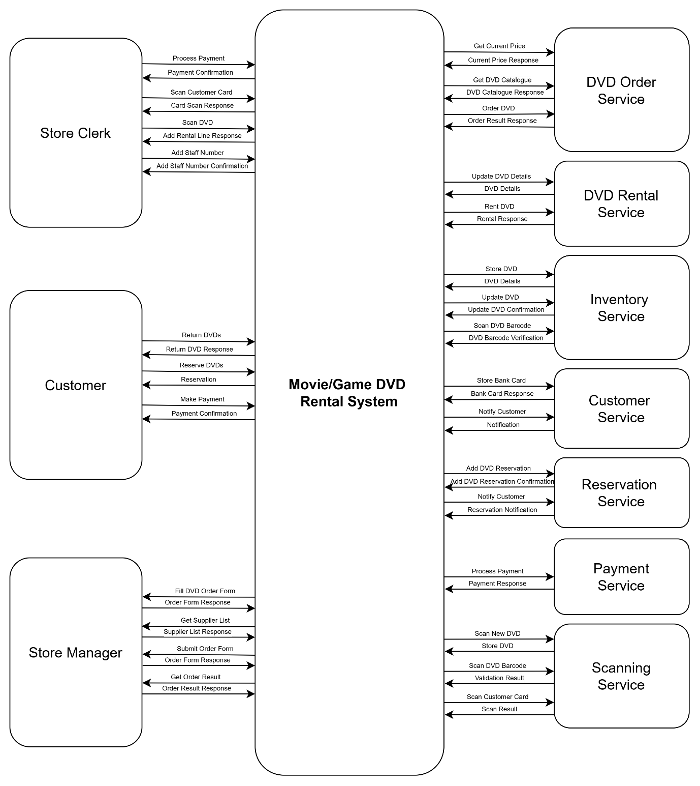

# **UML Activity Diagram with Horizontal Swimlanes**

## 1. DVD Ordering

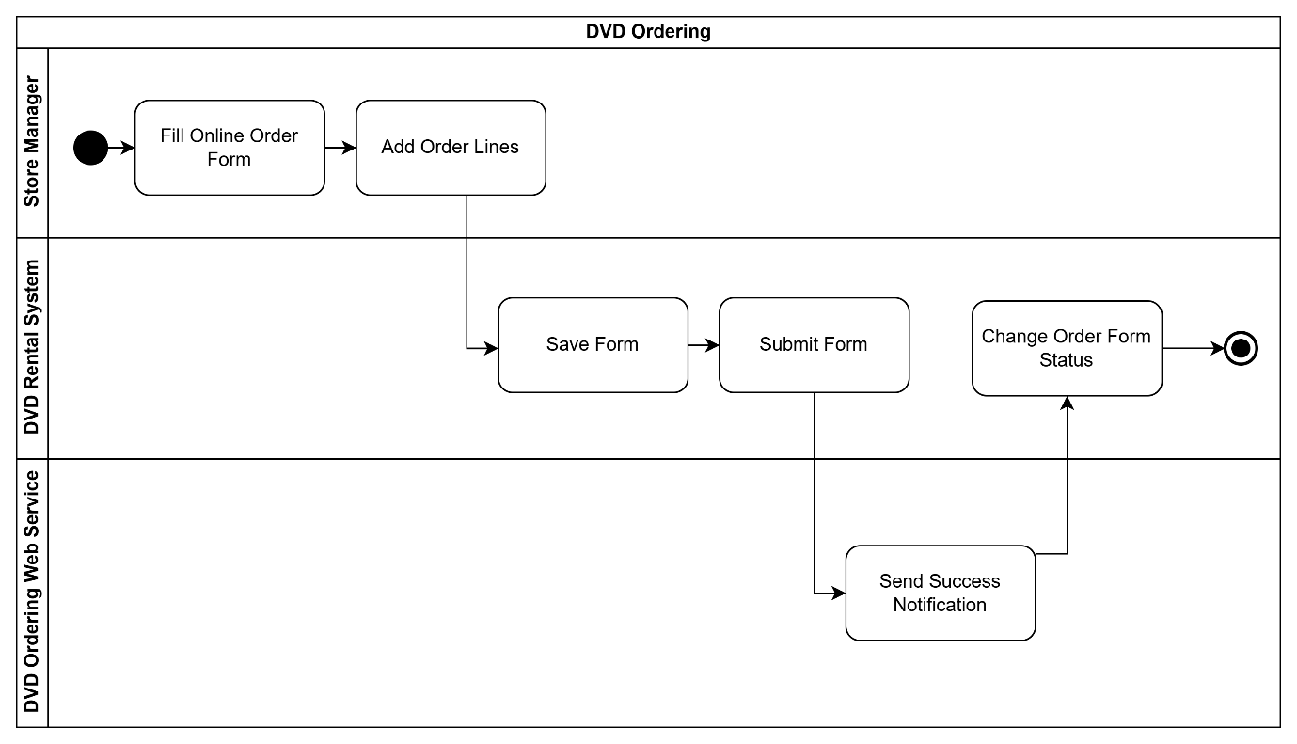

## 2. DVD Renting

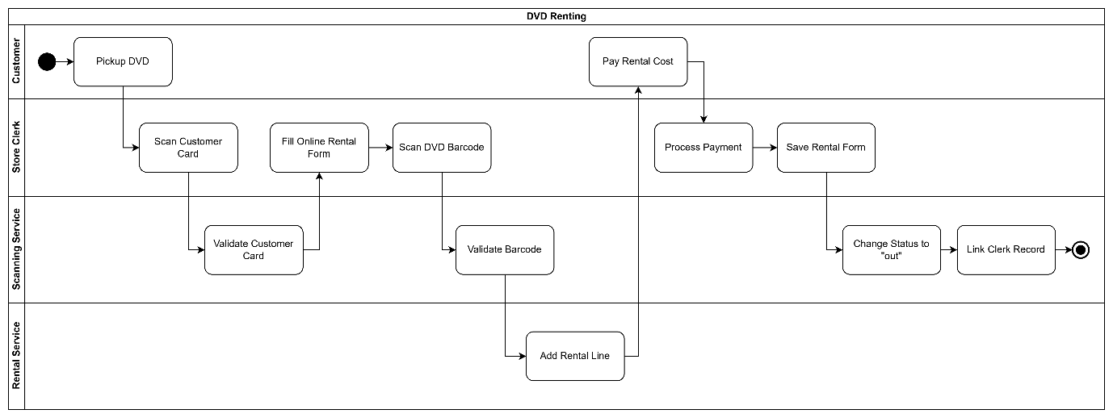

## 3. DVD Returning

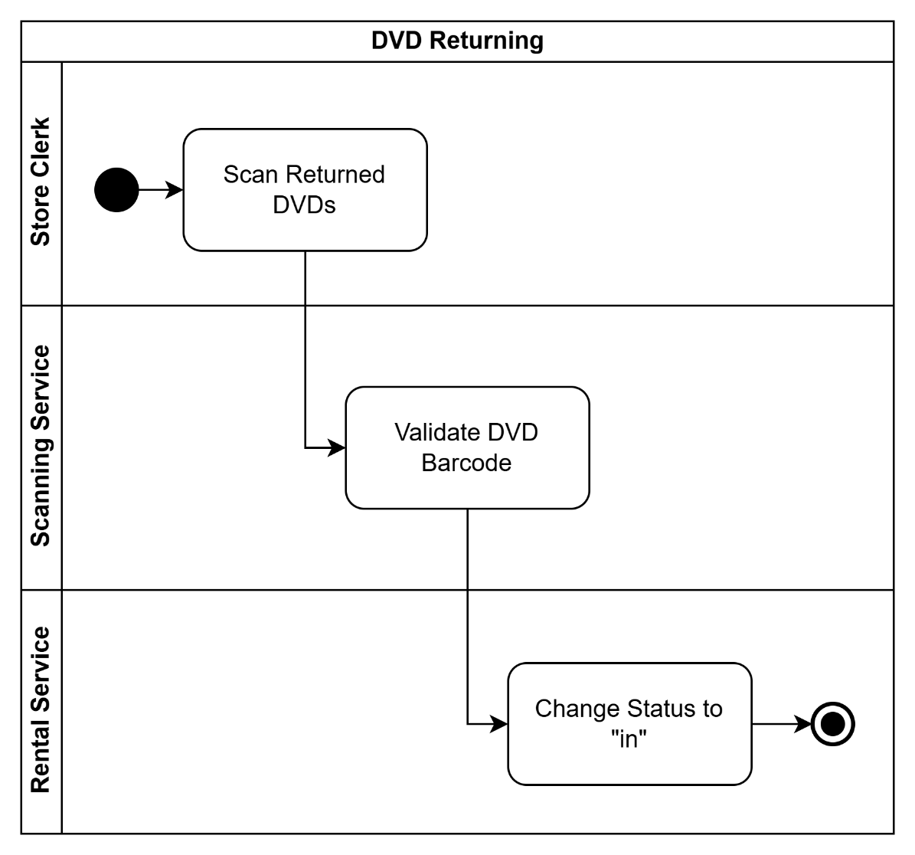

## 4. DVD Reservation

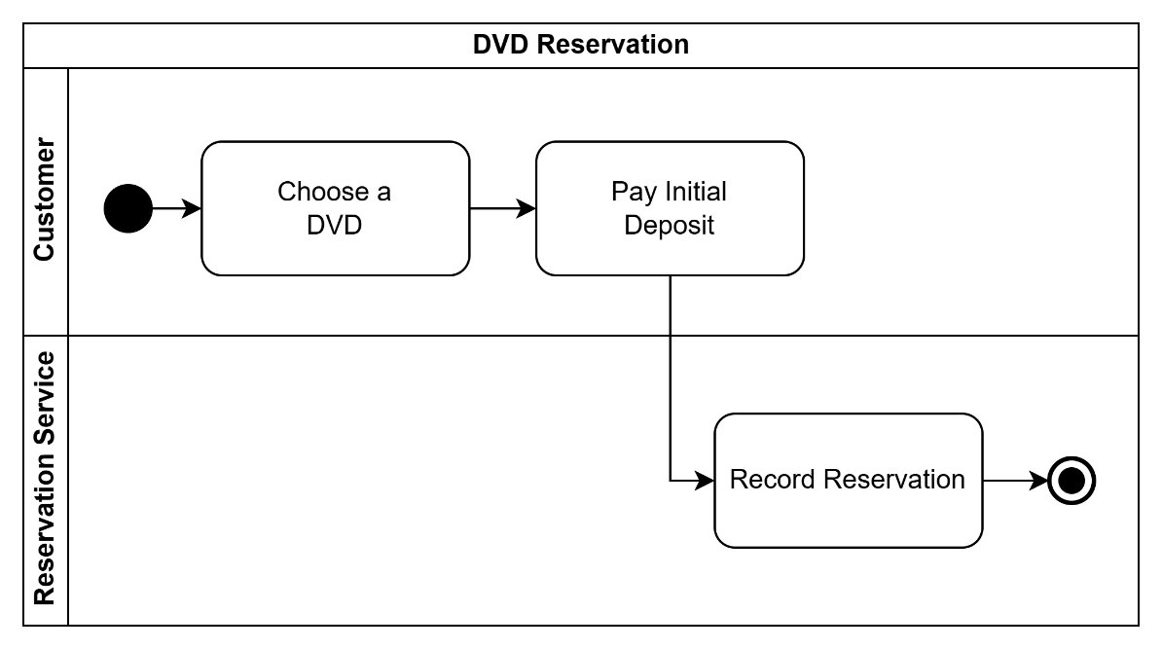

# **UML Use-Case Diagram**

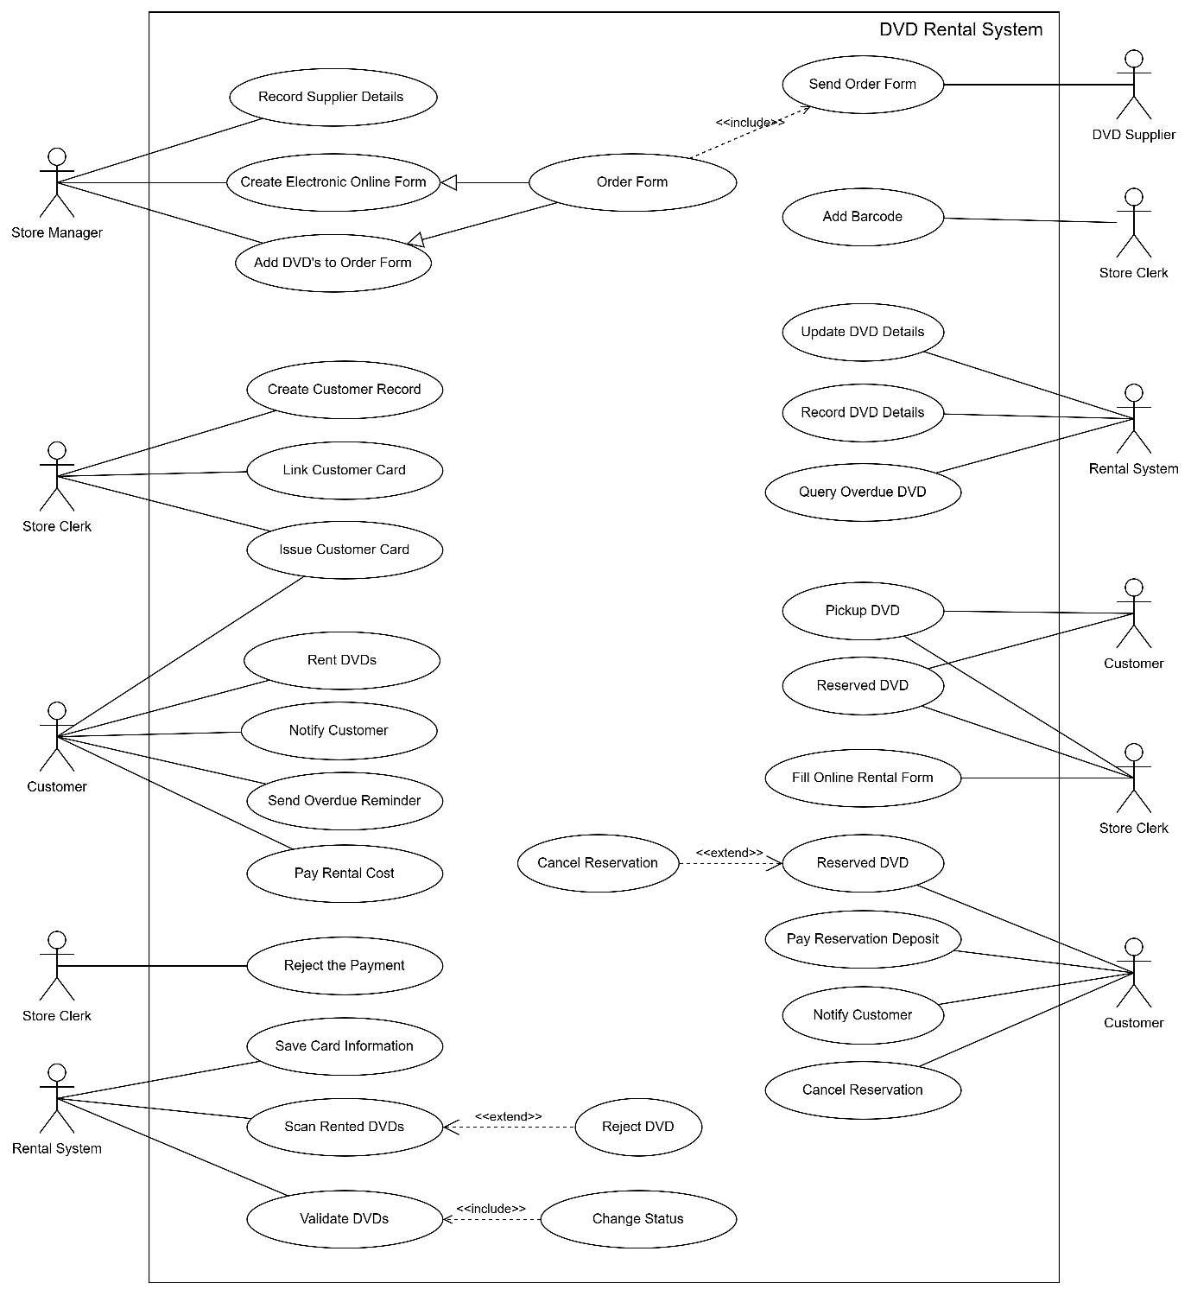

# **UML Activity Diagram with Vertical Swimlanes**

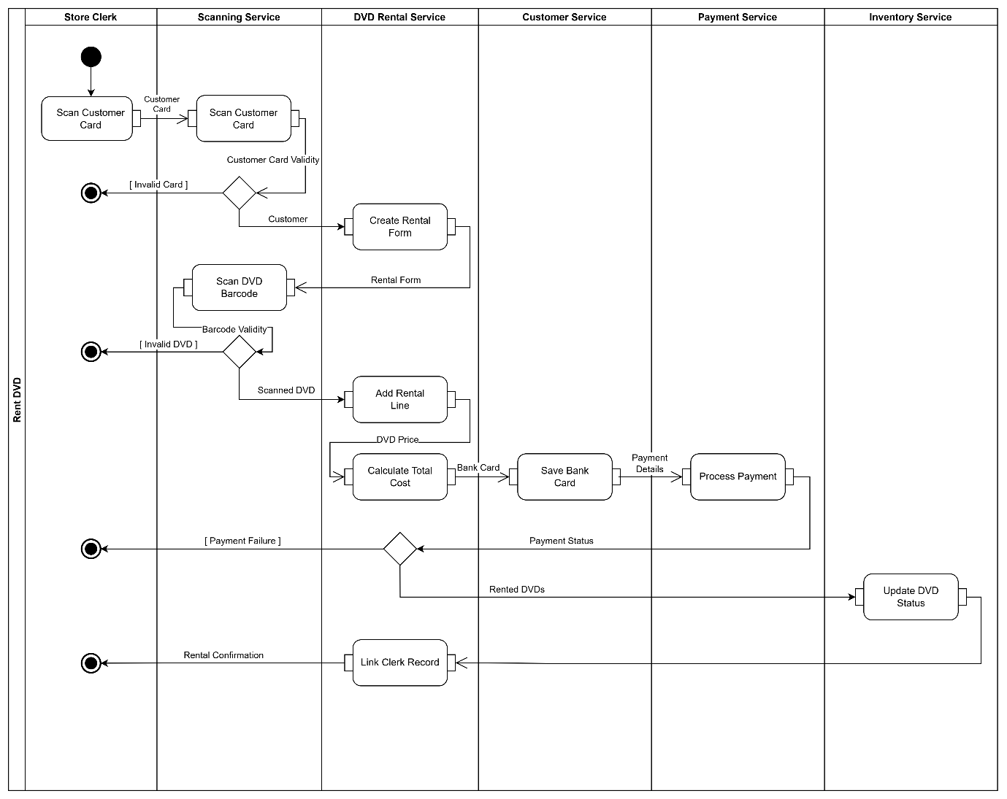

# **UML Class Diagram**

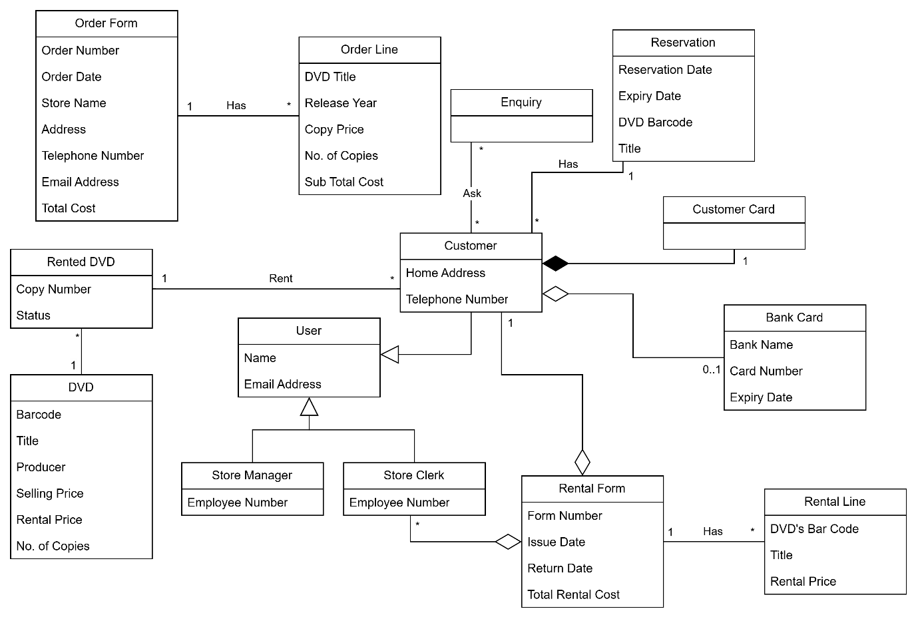

# **Service Interaction Diagram**

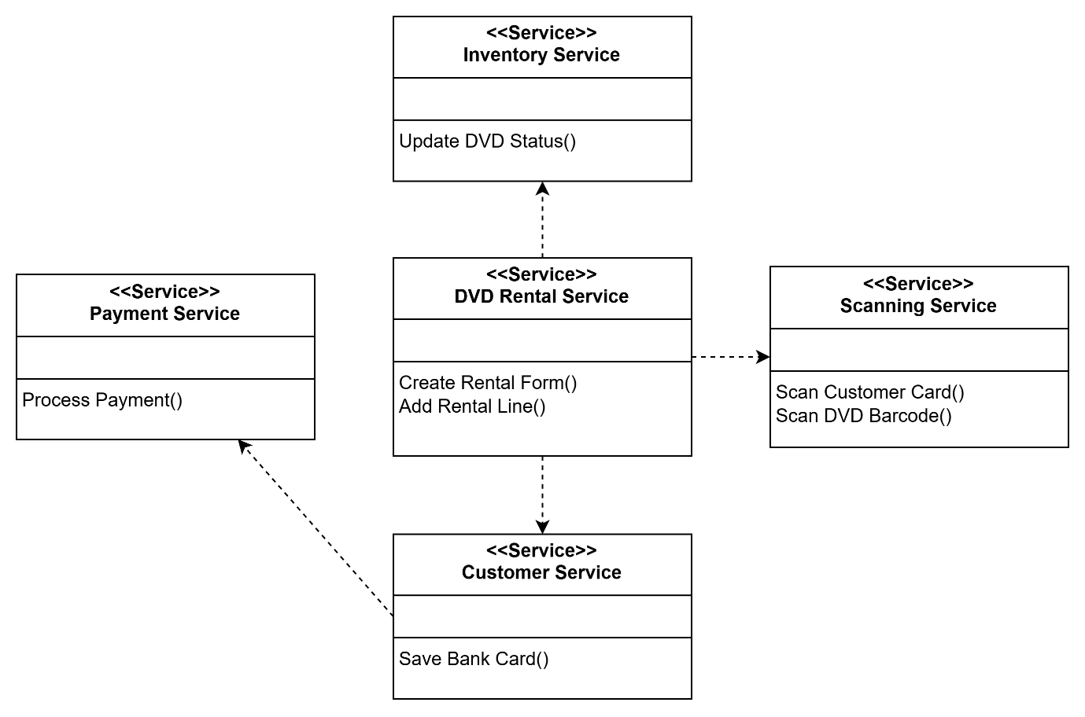

# **Service Interface Diagram**

## 1. DVD Rental Service

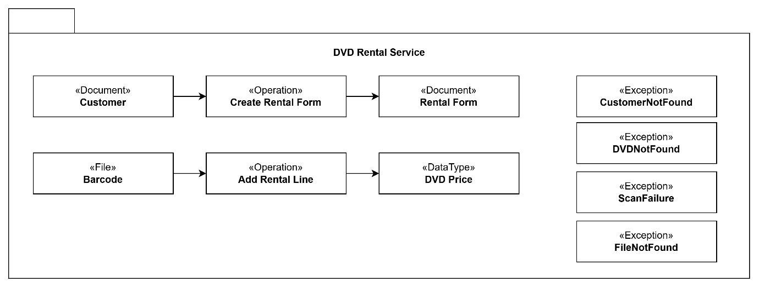

## 2. Customer Service

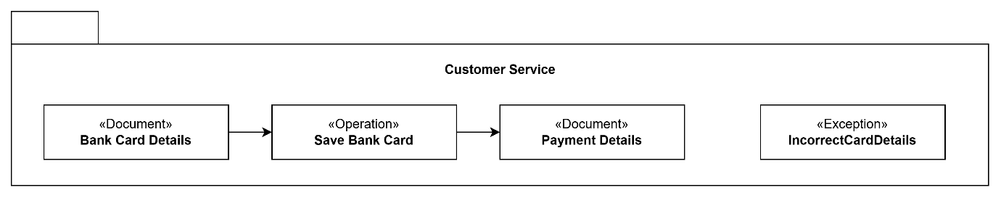

## 3. Scanning Service

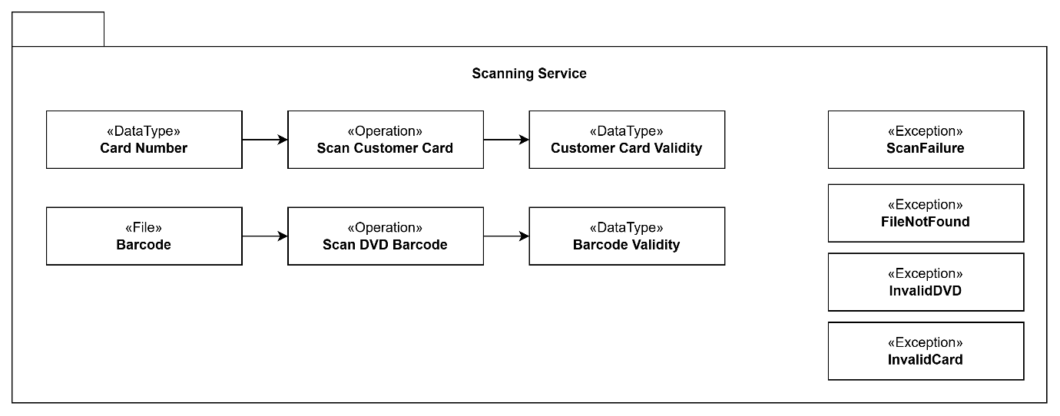

## 4. Inventory Service

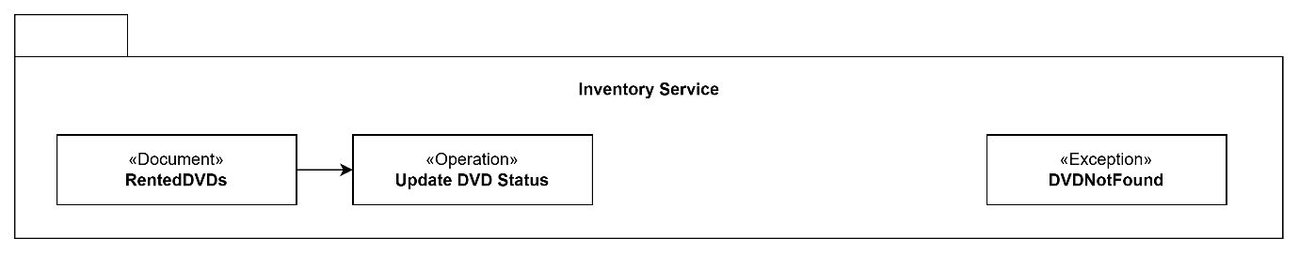

## 5. Payment Service

